

Group: Nicholas Agtual, Sofia Escobedo, Andres Mendoza, Christine Tan

ME 241 Materials Laboratory

Materials Survey by Charpy Impact Testing

Performed: October 19, 2021

Due: November 2, 2021

Table of Contents

Objective 3

Experimental Equipment 5

Procedure & Observations 8

Data & Results 9

Discussion of Results 11

Conclusion 12

Appendices 14

Appendix A: Sample Calculations 14

Appendix B: MATLAB CODE 15

References 17

List of Figures

Figure 1: Labeled Image of the Charpy Impact Tester 5

Figure 2: Close up of the Impactor on the Hammer 6

Figure 3: Close up of Dial Indicator 7

Figure 4: Sample Materials Prior to Impact Test 7

Figure 5: Sample Materials Post Impact Test 9

Figure 6: Bar Graph of Impact Energy for Sample Materials 10

List of Tables

Table 1: Impact Energy and State of Fracture for Sample Materials 10

Table 2: Conversion Factor from lb.-ft to Joules 10

Table 3: Modulus of Elasticity of Sample Materials [7] 11

# Objective

The goal of the Materials Survey by Charpy Impact Testing lab is to find a suitable material with an impact energy of at least 60 ft-lb from an array of potential samples. The impact energy of the materials will provide an idea of the “quantitative measure of the fracture resistance of materials” [1]. The impact energy will be examined using the Charpy Impact Testing machine [1], which instruments a pendulum striker. “The Charpy test is of great importance to evaluate the embrittlement of steels,” [1] by the response of the material to a dynamic impact force. For example, the Titanic might not have had such a tragic ending if engineers had tested the impact energy of the metallic sheets to anticipate the behavior under those same simulated conditions. The engineers would have determined the risk of failure due to the ductile transition of the metal to a brittle state when the metal is above a temperature of 0 degrees Celsius. “Material testing procedures were developed to collect information about the behavior of various materials, predominantly metals, operating at different external conditions” [1].

The pendulum striker contains a blade on the inside, which drops down with evolving force and then strikes the specimen. The specimen is hit on the opposite side of the notch and its placement is always perpendicular to the hammer direction of the pendulum. The specimen also needs to have a standard 10 × 10 × 50mm pre-machined size to be used in the tester. After the specimen is hit, the impact energy absorbed by the specimen can be determined. This is done using principles of energy conservation. By calculating the different in energy of the hammer from the initial position to right when it strikes the sample. The difference in energy is displayed in the dial indicator. The specimen may or may not be notched. If the specimen were to be notched, then the stress from the impact energy is directed to the notched part. The material toughness depends on three things: the notch, lattice structure, and the temperature. According to Henry Louis LeChatalier in 1892, “He found that some steels that showed ductile behavior (bending without fracture) in a smooth rectangular bar, would exhibit fragile behavior when the test specimen was notched” [2]. The fracture resistance of steels (or materials other than steels) can be measured even if the fracture is caused by a ferritic steel’s ductile or brittle transition.

Based on the material properties of the listed testing samples, it is predicted that the 304 Stainless steel and the 110 Copper Alloy will have the highest impact energy, while the notched PVC and the Hardwood Maple will have the lowest impact energies. The notched PVC is expected to have the lowest impact energy for two reasons. Firstly, PVC is inherently brittle and brittle materials are inferior to ductile materials when it comes to absorbing energy. Secondly, the notch in the sample material will create stress concentrations, lowering the impact energy. The low carbon steel (1018) and 304 stainless steel are predicted to have the highest impact energy as they have the largest modulus of elasticity of the samples and can thereby absorb the largest amount of energy. A breakdown of the Young’s Modulus of each sample material can be found in the Discussion of Results section of this lab report.

Another aspect of the test that is of interest is the extent to which the materials fracture and they type of fracture that they display. A fracture can be categorized in two ways; if the sample material splits into two, it is considered a complete fracture, and is incomplete otherwise. For a material that completely fractures there are many different types of fracture, but they can be considered to have clean cleavage or an amorphous rupture [5]. In crystalline solid, the atoms are neatly arranged, resulting in a smooth break upon brittle fracture [4]. For amorphous solids, there are not well-defined planes, resulting in a rough fracture [4]. This type of fracture can be described as powdery [5].

# Experimental Equipment

This experiment required the use of the Charpy Impact Tester, as shown in Figure 1, safety glasses, tongs, and the eight sample materials shown in Figure 4.

The Charpy Impact Tester used in a fully mechanical machine that is used to measure the impact energy required to plastically deform or fracture the sample. The Charpy Impact Tester is released at a constant height to ensure that each material is struck with the same amount of energy. Each sample absorbs a fraction of the energy before the sample fractures [6]. The amount of energy absorbed by the sample is recorded by a dial indicator.

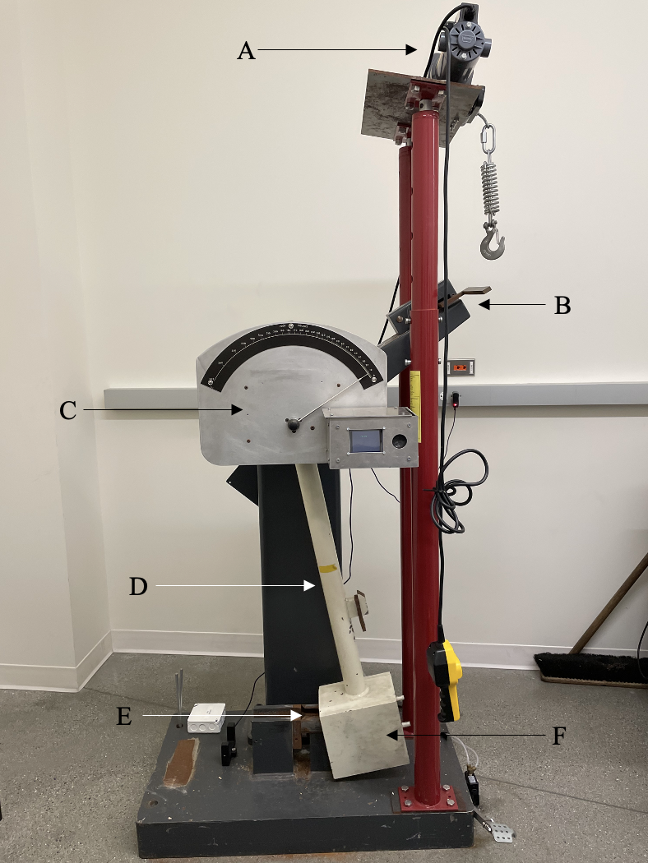

Figure 1: Labeled Image of the Charpy Impact Tester

The components of the Charpy Impact Testing (Figure 1) are described below:

1. The winch used to raise the hammer to a specified height. The height is held constant for each run, ensuring the hammer has the same potential energy every time.
2. The safety latch holds the arm at the specific height until the arm is ready to be released.
3. The dial indicator displays the amount of impact energy in lb.-ft that the sample can absorb.
   1. Figure 3 displays how the increments on the gauge of the dial indicator differ as the impact energy varies. For larger impact energies, the hatch marks are distance further apart.
4. The arm is fixed at one end and contains the hammer on the other. The length of the arm allows for the hammer to have an angular velocity that is perpendicular to the sample upon impact.
5. The stage that holds the sample in a standard position.
6. The hammer that strikes the sample.
   1. Figure 2 displays the portion of the hammer that impacts the sample material.

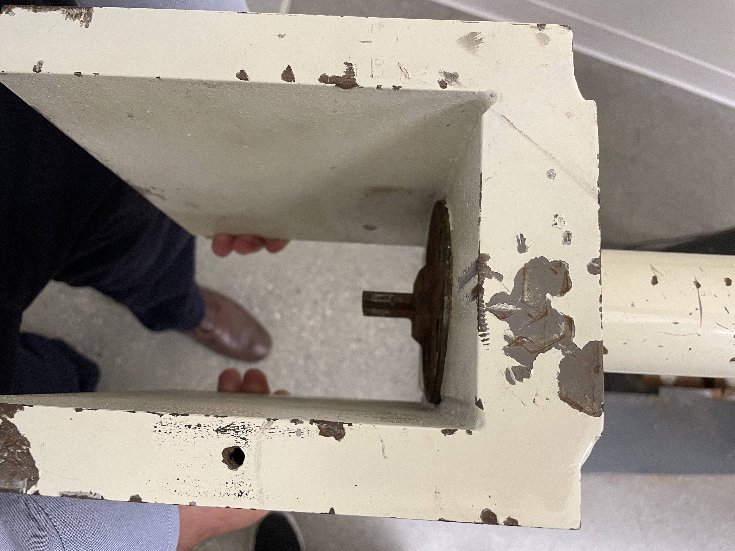

Figure 2: Close up of the Impactor on the Hammer

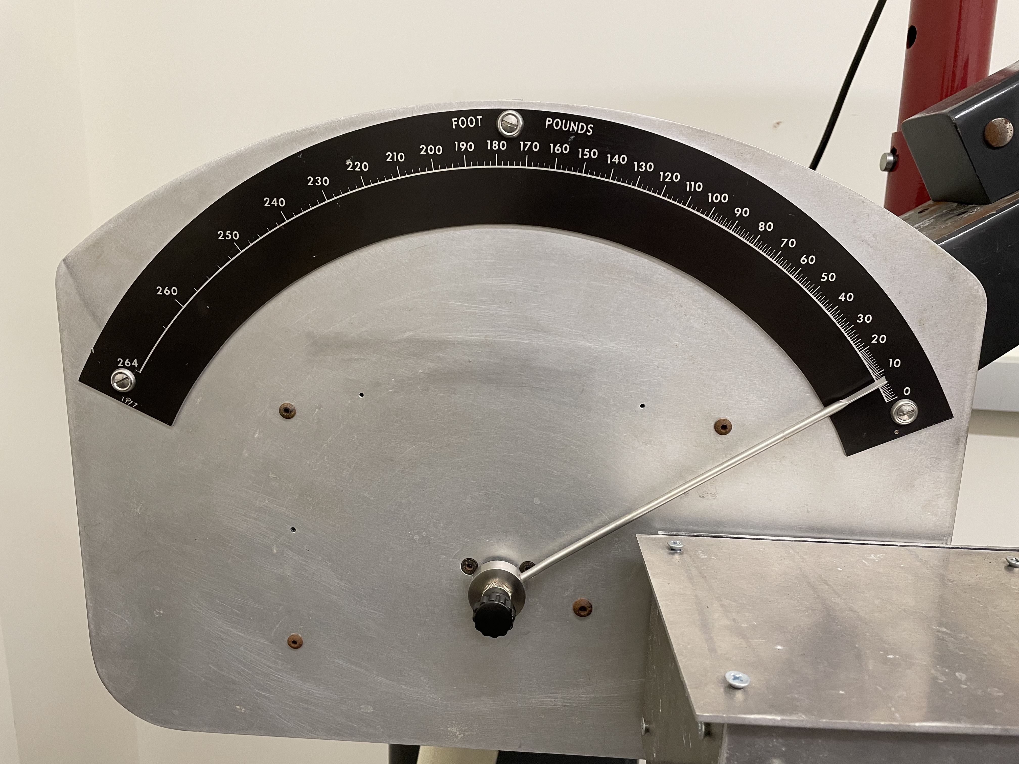

Figure 3: Close up of Dial Indicator

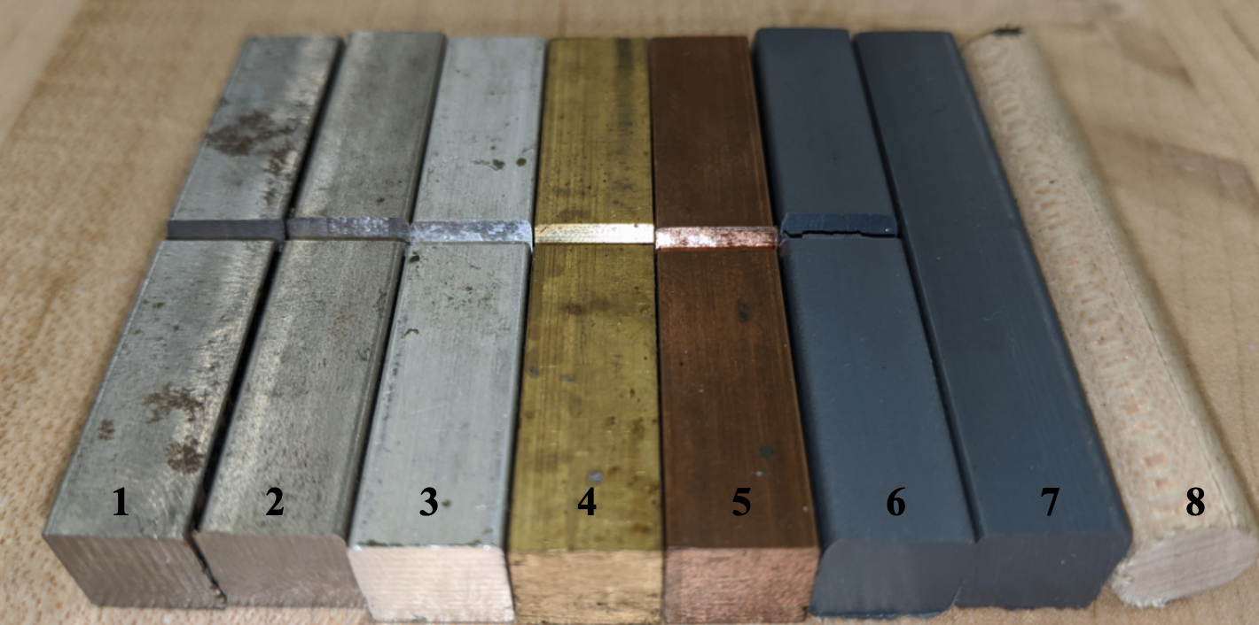

Figure 4: Sample Materials Prior to Impact Test

Each of these specimens are sized at 1 cm x 1 cm x 5.5 cm, except for the hardwood maple sample which is cylindrical with a 1 cm diameter and is 5.5 cm long. Each of the samples, with the exception of the unnotched PVC and hardwood maple, have a 2 cm V-shaped notch located in the middle of the sample. The specimens shown in Figure 4 are detailed below:

1. Low Carbon Steel (1018)
2. 304 Stainless Steel
3. 6061 Aluminum Alloy
4. 360 Free Machining Brass Alloy
5. 110 Copper Alloy
6. PVC (Notched)
7. PVC (Unnotched)
8. Maple Hardwood (Cylindrical Sample)

# Procedure & Observations

Prior to beginning the experiment, ensure that all the equipment discussed in the Experimental Equipment section is properly setup. Additionally, ensure that all participants are wearing proper PPE and keep a safe distance from the equipment while in use.

**Procedure:**

1. Place the first specimen into the into the fixture (Element E in Figure 1).
   1. If the specimen has a notch, place the not opposite to the side of impact. This will ensure that the sample deflects outward.
2. Lift the arm towards the right with the assistance of the winch and lock it into place using the safety latch. Remove any tension in the winch cable, ensuring that the latch is secure and remove the winch hook.
3. Move the dial indicator to the 264-ft-lb mark.
4. Move away from the side of the impact tester and release the arm, allowing the arm to swing and impact the specimen.
5. Record the dial indicator reading.
6. Collect the fractured specimen and take note of the facture shape.
7. Repeat steps 1-6 for all specimens.

# Data & Results

The experimental data collated through reading the gauge on the Charpy Impact Tester along with calculated values can be seen in Table 1. The data for the impact energy was originally collected in units of pound feet (lb.-ft) and was converted to units of Joules (J). The conversion factor from pound feet (lb.-ft) to Joules (J) can be seen in Table 2. After converting the impact energy in pound feet (lb.-ft) to Joules (J), new deviation values must be calculated to account for error propagation. The new error is calculated using Equation 1 (See Appendix A for sample calculations) [9].

|  |  |  |
| --- | --- | --- |
|  | $$δq=∣B∣δx$$ | Equation |

The rightmost column in Table 1 states whether the sample completely fractured or not. A fracture is considered complete when the sample completely split into two pieces upon impact. All the samples after impact are pictured in Figure 5 where the sample are arranged in the same order as in Figure 4. Samples 6 – 8 are both amorphous solids as opposed the crystalline structure of samples 1 – 5.

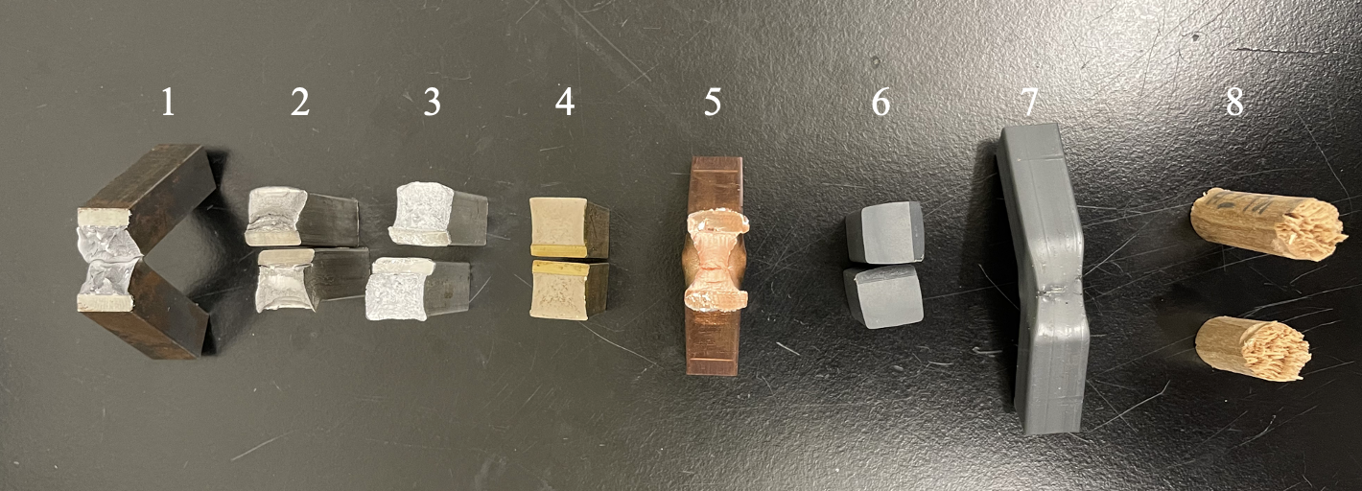

Figure 5: Sample Materials Post Impact Test

Table 1: Impact Energy and State of Fracture for Sample Materials

|  |  |  |  |
| --- | --- | --- | --- |
| **Material** | **Impact Energy (ft-lb)** | **Impact Energy (J)** | **Complete Facture** |
| **E ± 𝛿** | **E ± 𝛿** | **(Yes or No)** |
| Low Carbon Steel (1018) | 49.5 ± 2 | 67.1 ± 4.0675 | No |
| 304 Stainless Steel | 114 ± 2 | 154.6 ± 4.0675 | Yes |
| 6061 Aluminum Alloy | 20.5 ± 2 | 27.8 ± 4.0675 | Yes |
| 360 Free Machining Brass Alloy | 12.5 ± 2 | 16.9 ± 4.0675 | Yes |
| 110 Copper Alloy | 127 ± 2 | 172.2 ± 4.0675 | No |
| PVC (Notched) | 5.5 ± 2 | 7.5 ± 4.0675 | Yes |
| PVC (Un-Notched) | 39.75 ± 2 | 53.9 ± 4.0675 | No |
| Hardwood Maple | 8.5 ± 2 | 11.5 ± 4.0675 | Yes |

Table 2: Conversion Factor from lb.-ft to Joules

|  |  |
| --- | --- |
| **Conversion Factor** | |
| 1 lb.-ft = 1.35582 J | 1 J = .737562 |

Figure 6: Bar Graph of Impact Energy for Sample Materials

# Discussion of Results

The results of this experiment showed that the notched PVC has the lowest impact energy while the 110 Copper Alloy had the highest impact energy. These results partially align with the predictions made based on Young’s Modulus. It was predicted that the Low Carbon Steel (1018) and the 304 Stainless Steel would have the highest impact energy since they have the highest modulus of elasticity, meaning they are the most ductile, meaning they can absorb the most energy. In reality, the 110 copper alloy had a higher impact energy than the low carbon steel. This could have been due to the crystal structure of the low carbon steel (1018). 1018 low carbon steel has a BCC crystal structure compared to the FCC crystal structure of the 110 copper alloy and the 304 stainless steels. Materials with FCC crystal structure are typically able to absorb more energy that materials with BCC crystal structure [4]. The prediction of the notched PVC having the lowest impact energy was found to be true. The modulus of elasticity of the sample material can be seen in Table 3.

Table 3: Modulus of Elasticity of Sample Materials [7]

|  |  |
| --- | --- |
| **Material** | **Modulus of Elasticity** |
| Low Carbon Steel (1018) | E = 205 GPa |
| 304 Stainless Steel | E = 193 GPa |
| 6061 Aluminum Alloy | E = 68.9 GPa |
| 360 Free Machining Brass Alloy | E = 117 GPa |
| 110 Copper Alloy | E = 120 GPa |
| PVC (Notched) | E = .003 – 4.83 GPa |
| PVC (Un-Notched) | E = .003 – 4.83 GPa |
| Hardwood Maple | E = 10 – 12 GPa |

One interesting finding is the difference in impact energy between the notched and un-notched PVC samples. The un-notched PVC had an impact energy around 7.25 times greater than that of the notched PVC sample. The reason for the unnotched sample not experiencing complete fracture is most due to the lack of stress concentrations that the notch induces.

Although the results of the experiment proved to be in line with accepted empirical results, there was still some deviation present. This deviation can be due to many factors such as the condition the test was conducted in; however, the only factor that will be discussed in this lab report is experimental error. The experimental error for the impact energy was set at plus or minus three-pound feet, which turns out to be 4.067 in Joules. This value accounts for any variation in reading the gauge, variation in setting up the sample, and variation in the sample, among other factors. Since the scale of the gauge varied depending on the impact energy, it is difficult to get an accurate reading. The reading of the impact energy could have also been affected by any small variation in how the sample material was mounted. Since there is a standard size for samples tested using the Charpy impact test, any small deviation in the dimensions of the sample, small scratches, or knicks could affect the impact strength of the material. Another factor that could have affected the results is maintenance of the machine. Although the potential energy for each setup would have been the same, any friction generated due to lack of lubricant would have affected the kinetic energy at impact. All these factors could slightly change the experimental values and are accounted for.

# Conclusion

The results of impact testing used in design can be seen in everyday life. A practical application of this experiment is crash barriers along the sides of freeways and roads. The crash barriers are meant to absorb energy and cause as little damage to the car and person inside as possible. The material used for these barriers is meant to bend and change shape, rather than exhibiting brittle fracture. If the metal used were to be too hard it could cause more injuries, but if it were too soft it would not absorb as much energy, causing the car to go through the barrier. An impact test was most likely one of the tests implemented to identify a metal best fit for this application.

In this experiment, the company requires a material with an impact energy of at least 81.34 J or 60 ft-lb. The results of this experiment found that only the 304 Stainless Steel and 110 Copper Alloy are suitable for a first screening, with a 60 lb.-ft impact energy requirement. Since both materials well exceeded the impact energy requirement, other factors should be considered when selecting the final material for the component. These factors include but are not limited to cost of the component, conductivity requirements, corrosion resistance, and weight.

# Appendices

## **Appendix A: Sample Calculations**

**Impact Energy in Joules:**

$$ImpactEnergy_{J}=ImpactEnergy_{lb.-ft}*1.35582 \frac{J}{lb.-ft}$$

$$ImpactEnergy_{J}=49.6 lb.-ft*1.5582 \frac{J}{lb.-ft}$$

$$ImpactEnergy_{J}=67.1 J$$

**New Deviation for Impact Energy in Joules:**

$$δq=∣B∣δx$$

$$δ ImpactEnergy_{J}= ∣1.35582∣*2$$

$$δ ImpactEnergy_{J}=2.7166$$

## **Appendix B: MATLAB CODE**

close all; clear;

Data

% Impact Energy in lb-ft

impactEnergy = [49.5 114 20.5 12.5 127 5.5 39.75 8.5];

% Sample Materials

materials = categorical({'Low Carbon Steel (1018)', '304 Stainless Steel', ...

'6061 Aluminum Alloy', '360 Free Machining Brass Alloy', ...

'110 Copper Alloy', 'PVC (Notched)', 'PVC (Un-Notched)', ...

'Hardwood Maple'});

% Maintains order of sample materials for bar graph

materialsOrdered = reordercats(materials, {'Low Carbon Steel (1018)',...

'304 Stainless Steel', '6061 Aluminum Alloy', '360 Free Machining Brass Alloy', ...

'110 Copper Alloy', 'PVC (Notched)', 'PVC (Un-Notched)', ...

'Hardwood Maple'});

Plot

% Creates figure

figure(1)

% Creates bar graph

barGraph = bar(materialsOrdered, impactEnergy);

hold on;

% Creates grid

grid on;

% Defines grid size

grid minor;

% ----- Displaying Values -----

% Finds the x-coordinates of each bar

xTips = barGraph.XEndPoints;

% Finds the y-coordinates of each bar

yTips = barGraph.YEndPoints + 2.75;

% Asgines the label of each bar as the impact energy

labels = string(barGraph.YData);

% Displaying values at tips of bars

text(xTips, yTips, labels, 'HorizontalAlignment', 'center', ...

'VerticalAlignment', 'bottom', 'FontName', 'Times');

% ----- Error Bars -----

% Defines error as 3

deltaImpactEnergy = 3;

% Creates positive error of 3

errorHigh = ones(1, length(impactEnergy)) * deltaImpactEnergy;

% Creates negarive error of -3

errorLow = ones(1, length(impactEnergy)) * -deltaImpactEnergy;

% Creates errror bars

error = errorbar(materialsOrdered, impactEnergy, errorLow, errorHigh);

% Makes error bars black

error.Color = [0 0 0];

% Disconnectes error bars for each material

error.LineStyle = 'none';

% ---- Plot Descriptors -----

% Creates Y-Axis Label

ylabel(' {Impact Energy (lb-ft)}', 'fontsize', 11, 'FontName', 'Times', 'Interpreter', 'latex');

% Creates X-Axis Label

set(gca, 'XTickLabel', materialsOrdered, 'XTick', barGraph.XData, 'FontSize', 11, ...

'TickLabelInterpreter', 'latex');

% Creates Plot Title

title('{Impact Energy (lf-ft) of Various Material Types}', 'fontsize', 14, ...

'FontName', 'Times', 'Interpreter', 'latex');

% Generates and positions legend

legend('Experimental Data', 'Error Bars', 'location','northeast');

Calculations

% Converting impact energy from lb-ft to Joules

% 1 ft-lb = 1.35582 J

impactEnergyJ = impactEnergy * 1.35582;

% Calculating the new error for conversion

deltaImpactEnergyJ = abs(1.35582) * deltaImpactEnergy;

# References

1. Francois, D., & Pineau, A. (2002). *From Charpy to Present Impact Testing (Volume 30) (European Structural Integrity Society, Volume 30)* (1st ed.) [E-book]. Elsevier Science.
2. Thomas A. Siewert (Editor), Michael P. Monahan (Editor). (2000). *Pendulum Impact Testing: A Century of Progress (Astm Special Technical Publication// Stp)* [E-book]. ASTM International.
3. M. Atwater, “Conditioning Materials” in Materials and Manufacturing: An Introduction to How They Work and Why It Matters, (McGraw-Hill Professional, 2019), Chapter 9.
4. W. D. Callister, D. G. Rethwisch, “Mechanical Properties of Metals” in Materials Science and Engineering: An Introduction, (Wiley, Ed. 8, 2009).
5. Lab Manual (Camacho, 2021).
6. LabTesting, Impact Testing. <https://www.labtesting.com/services/materials-testing/mechanical-testing/impact-testing/>, (accessed 24 October 2021).
7. Matweb: Material Property Data. <http://www.matweb.com/index.aspx> (accessed 28 October 2021).
8. K. Herrmann, “The Fundamentals of Hardness Testing” in Hardness Testing: Principles and Applications, (ASM International, 2010), Chapter 1.
9. J. R. Taylor, “Principal Formulas in Part 1” in An Introduction to Error Analysis: The Study of Uncertainties in Physical Measurements, (University Science Books, 1996), Vol. 9, Chapter 3.